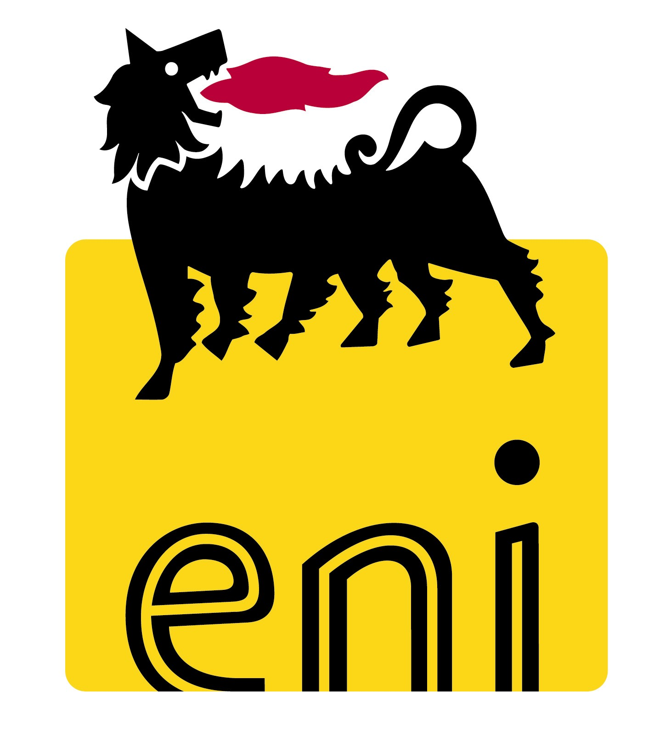

Eni: Financial Calendar 2013

Review and announcement of 2013 financial results
San Donato Milanese (MI), 14 December 2012 - Eni announces the dates for the publication of its 2013 financial results as approved by the Board of Directors and at the Shareholders’ Meeting:

Fourth quarter 2012 results and preliminary financial statements as at December 31, 2012  Dividend announcement for the 2012 financial year | Meeting of the Board of Directors | February 14, 2013
 | Press release and conference call* | February 15, 2013
Consolidated financial statements as at December 31, 2012 and draft financial statements as at December 31, 2012  Dividend proposal for 2012 | Meeting of the Board of Directors | March 14, 2013
 | Press release and strategy presentation | March 14, 2013
First quarter 2013 results | Meeting of the Board of Directors | April 24, 2013
First quarter 2013 results | Press release and conference call | April 24, 2013
Financial statements as at December 31, 2012 | Ordinary Shareholders’ Meeting | May 10, 2013  (single call)
Financial statements as at December 31, 2012 | Press release | May 10, 2013

Second quarter 2013 results and interim financial report as at June 30, 2013  Interim dividend announcement for the financial year 2013 | Meeting of the Board of Directors | July 31, 2013
 | Press release and conference call* | August 1, 2013
Board resolution on 2013 interim dividend | Meeting of the Board of Directors | September 19, 2013
Board resolution on 2013 interim dividend | Press release | September 19, 2013
Third quarter 2013 results | Meeting of the Board of Directors | October 29, 2013
Third quarter 2013 results | Press release and conference call* | October 30, 2013

* Press Releases will be issued in the morning (non trading hours) and a conference call for the presentation of results to the financial community will be held in the afternoon.

The balance of the dividend for the 2012 financial year will be paid on May 23, 2013 (ex-dividend date: May 20, 2013; record date: May 22, 2013) and the interim dividend for the 2013 financial year will be paid on September 26, 2013 (ex-dividend date: September 23, 2013; record date: September 25, 2013).

Any amendments to the above calendar will be notified to the market.

Company Contacts:

Press Office: Tel. +39.0252031875 – +39.0659822030
Freephone for shareholders (from Italy): 800940924
Freephone for shareholders (from abroad): +39. 800 11 22 34 56
Switchboard: +39-0659821
ufficio.stampa@eni.com
segreteriasocietaria.azionisti@eni.com
investor.relations@eni.com

Web site: www.eni.com



